Bredon, Bredon’s Norton and Westmancote Parish Council

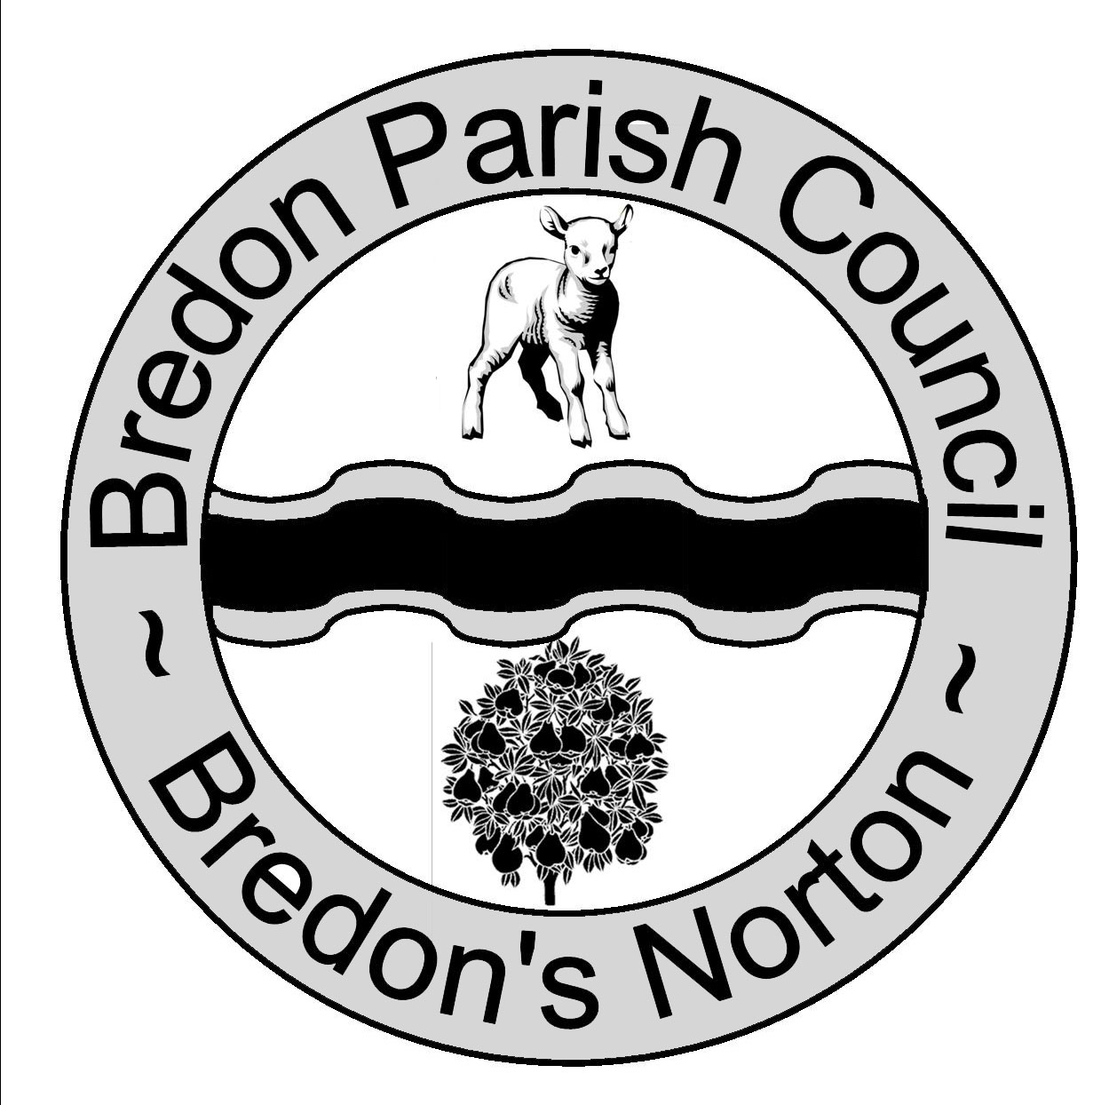 Chairman Mr P Handy Clerk Ms J Shields
Bredon Village Hall
Main Road
Bredon
Nr Tewkesbury
Glos
GL20 7QN
01684 773984
Bredonpc@btconnect.com
.com

You are duly summoned to attend Bredon Parish Council meeting to be held at Bredon Village Hall on Monday 1st February 2016 at 7.15pm.

Residents are invited to give their views and to question the Parish Council on issues on the Agenda; additionally they can, at the discretion of the Chairman, raise issues for future consideration. There will be a time limited of 5 minutes per item and 15 minutes in total.

Members of the public may not take part in the Parish Council meeting itself but are welcome to

attend.

AGENDA

- Apologies For Absence.
- Declaration Of Interests.
- Register Of Interests: Councillors Are Reminded Of The Need To Update Their Register Of Interests.
- To Declare Any Disclosable Pecuniary Interests In Items On The Agenda And Their Nature.
- To Declare Any Other Disclosable Interests In Items On The Agenda And Their Nature.
Councillors who have declared a disclosable pecuniary interest, or any other disclosable interest which falls within the terms of paragraph 12(4) (b) of the code of conduct, must leave the room for the relevant items.
Failure to register or declare a disclosable pecuniary interest may result in the commission of a criminal offence.
- To Consider Application For Dispensation.
- To Consider The Adoption Of The Minutes Of The Meetings Held On The 4th January 2016.
- Finances.
- To agree Invoices To Be Paid.
- Financial Report.
- To Discuss Fields in Trust.
- To Receive A Report On Progress To-Date And Agree Next Steps On The Fitness Equipment For The Playing Field.
- Correspondence For Information.
- To Consider A Memorials Policy.
- To Discuss The New Homes Bonus Request From Wychavon. (Football Club).
- To Discuss The Future Of The Village Hall And Forming A New Working Party.
- To Discuss The Councils Vision/Plan For The Five Year Term.
- Planning.
- For Consideration.
W/15/03096/CU - Corner Cottage, Lower Lane, Kinsham, Tewkesbury.
W/15/03233/OU - Avonvale Farm, Tewkesbury Road, Bredons Hardwick.
- Decided By Wychavon.
- Neighbourhood Plan.
- Progress Reports For Information.
- Clerk.
- Bredon Village Hall.
- Bredons Norton Village Hall.
- County and District Councillor.
- New Homes Bonus. 2013-2014, 2014-2015, 2015-2016 and 2016-2017.
- Lease.
- Tennis Club Update.
- BCPR.
- BHCG.
- Grass.
- Common Land Register.
- Website.
- Parish Magazine.
- Councillors Reports And Items For Future Agenda.
Each councillor is requested to use this opportunity to report minor matters of information not included elsewhere on the agenda and to raise items for future agendas. Councillors are respectfully reminded that this is not an opportunity for debate or decision making.
- Date Of Next Meeting.
- Date Of Annual Parish Meeting.

