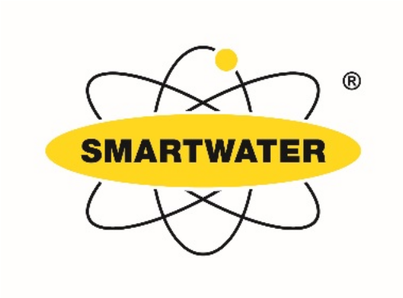
Smartwater is going to be available to homes in Bredon Parish soon.
West Mercia Police will help coordinate the role out of the project in January 2019.
We are seeking local volunteers to help with the distribution of these FREE Smartwater kits.
We will hold drop in sessions at Bredon and Bredon’s Norton Village Halls,
but will also call in at houses around the Parish to deliver the kits.
Especially to our elderly residents.
If you can help, or have any questions relating to the project, please contact:-
Kevin Falvey on 07778 554324 or Email: kevin.falvey@btinternet.com

