Bredon & Bredon’s Norton
Parish Council

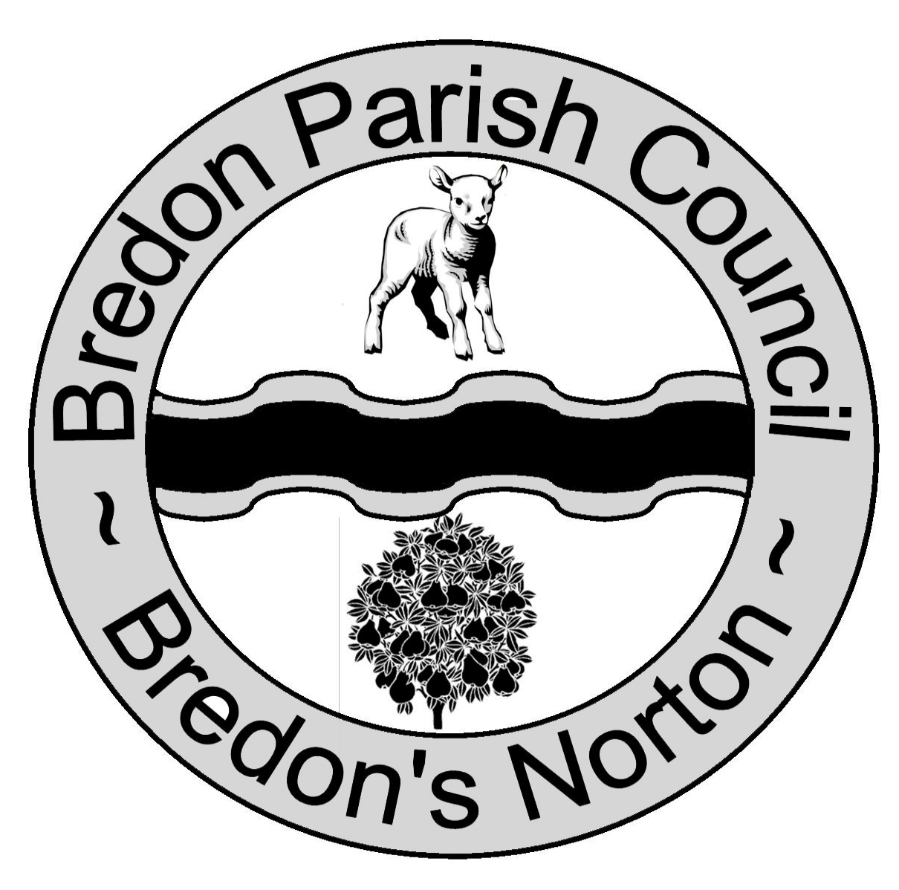
Bredon Village Hall
Main Road
Bredon
Tewkesbury
GL20 7QN

01684 773 984

bredonpc@btconnect.com

Chairman: Cllr N Bradley
Clerk: Mr T Drew

Planning
Tewkesbury Borough Council

By email to:
developmentapplications@tewkesbury.gov.uk

20 October 2020

Dear Sir or Madam

RE: 20/00896/FUL. Development of a road bridge over the mainline railway, North of Ashchurch.

- The application site is located approximately 100m south and 200m east of the Bredon & Bredon’s Norton parish boundary. Any future western link road would connect with roads within the parish.

- The effects of the proposal are likely to be experienced very noticeably within Bredon & Bredon’s Norton parish. We trust the Parish Council’s views will be given particular consideration.

- The Parish Council objects to the proposal for the following reasons.

Lack of sequencing

- The scheme has not followed the usual sequential approach typically adopted for this type of infrastructure project. It would appear to be a case of putting the cart before the horse.

- The 826 homes that the scheme hopes to unlock have not yet been allocated through any statutory planning process. The applicant’s Transport Assessment [4.3.3] states, “the residential development had not been designed in any detail at the time of writing and no masterplan was available.”

- The real barrier to new housing at Ashchurch, as every local person knows, is the severe lack of capacity on the Strategic Road Network around Ashchurch. Until this issue has been resolved, the new housing which the bridge is intended to enable cannot be delivered sustainably. For a number of years, there have been discussions about diverting the A46 in order to bypass pinch points at Ashchurch. As yet, no firm proposals exist, no preferred route has been identified and no funding has been allocated. Any off-line upgrade to the A46 would be a number of years in the future.

- Large additional sums will be required to construct the link roads to the bridge. The Parish Council understands that no funding has been secured for these road links. Furthermore, TBC planners have confirmed that landowner agreements are not in place for any road connections to the proposed bridge.

- At best, the 826 houses which the bridge is meant to enable can be considered a medium-term aspiration. At worst, the housing will not be delivered and the project will end up being a ‘bridge to nowhere.’

Negative impacts on the highway network

- The Strategic Road Network already suffers from a lack of capacity in the Ashchurch area, with congestion pinch points along the A46 and at M5 Junction 9 causing particular difficulties for local people and businesses.

- The stated aim of the bridge is to unlock the development of 826 new houses on land to its east, by dispersing some of the associated traffic through Northway. It is widely accepted that the larger part of this westbound traffic will gravitate towards the A46 by means of minor roads within Northway. In other words, the new housing will add to the existing congestion along the trunk network at Ashchurch.

- The applicant’s Transport Assessment acknowledges that the new bridge combined with 826 houses on land to the east would add more traffic to the Strategic Road Network during the key PM peak.

- The main problem with the proposal is that the bridge does not add capacity to the road network where it is actually needed. It mainly facilitates east-west movements for which there will be little future need. This is borne out by the road network traffic modelling study undertaken for the Garden Town’s Concept Masterplan Report. The report states (p38):

The most significant intervention tested in the study was a new Northern Access Road proposal to cross the railway, connecting between Aston Fields Lane and Hardwick Bank Road and effecting closure of the level crossing. This provides an alternative east-west route and distributes traffic movements more widely across the road network. However, the modelling results indicated that this intervention would not be able to support additional growth taking place on the western MOD site (900 homes), leading to significant congestion and delays. [emphasis added]

- Increased congestion on local roads would lead to a reduction in road safety. Additional traffic queuing to exit the M5 at Junction 9 would present a particularly significant risk. Increased congestion at pinch points would also encourage rat-running via the B4080, B4079 and the narrow country roads and village centres south of Bredon Hill. This would in turn significantly increase risk to cyclists and pedestrians using these roads.

- The proposal does not appear to satisfy the requirements of either the Gloucestershire Local Transport Plan or the Joint Core Strategy (Transport Strategy) with regard to the Strategic Road Network at Ashchurch.

Poor use of public funds

- The cost of phase one of the scheme is estimated at £8m. A similar sum will be needed for completing the scheme. Large additional sums will be needed to fund the connecting roads. Even if 826 new houses are delivered, this represents a very poor return on public investment. These funds would be much better spent on ameliorating the significant pinch-points in the strategic road network.

- Needless to say, if the project ends up as a ‘bridge to nowhere’, public anger at the misuse of desperately needed funds at this time should not be underestimated.

Local governance concerns

- It is not clear which local authority is the competent body to consider this application under Regulations 3 and 4 of the Town and Country Planning General Regulations 1992. The bridge will clearly play a strategic role in road development overseen by Gloucestershire County Council. Gloucestershire County Council may be the more appropriate body to consider the application. Tewkesbury Borough Council should take legal advice on this point and make this publicly available prior to determination. Unless this question is satisfactorily addressed, the application may be subject to legal challenge.

- As Tewkesbury Borough Council is heavily invested in the application, there will be a general public scepticism that the council is able to deal with this matter impartially. To avoid the appearance of impropriety, the Parish Council will be urging the Secretary of State to call-in this matter for determination under Section 77 of the Town and Country Planning Act 1990.

Harm to the Cotswolds AONB and landscape

- The proposed bridge is located approximately 1.6 miles from the boundary of the Cotswolds AONB and clearly falls within its setting. The site is overlooked by Bredon Hill, a well-known beauty spot and visitor destination within the AONB.

- The Cotswolds AONB Landscape Strategy and Guidelines confirms that views from the Cotswolds escarpment, including escarpment outliers such as Bredon Hill, are one of the ‘special qualities’ of the AONB. In other words, such views are one of the aspects of the AONB’s natural beauty which make the area distinctive and which are valuable at a national and international level. They constitute a key attribute on which the priorities for the AONB’s conservation, enhancement and management should be based.

- It is noted that the proposed bridge will be more than 11m high – the equivalent of three double-decker buses stacked on top of one another. Connecting roads would need to be raised up on a pair of 10m high embankments. The applicant’s Landscape and Visual Appraisal [3.1.3] states that the overall width of the structure would be 74m. The bridge is intended to unlock significant quantities of housing to the east.

- The bridge, embankments and housing development would have significant adverse visual effects on receptors within the AONB. The associated housing would also lead to increased rat-running through the AONB, as noted above. In the Parish Council’s view, the scheme would cause significant harm to the special qualities of the AONB.

Harm to and biodiversity

- Kemerton Conservation Trust, a locally-based wildlife charity, has submitted extensive evidence to the Tewkesbury Borough Local Plan consultation demonstrating that the lower Carrant valley, which includes the proposal site, is of exceptional landscape, historical and ecological importance. From this evidence, it is clear that the bridge proposal and associated development would result in unacceptable harms to landscape and ecology. In particular, the bridge and link road would lead to the loss of habit for the vale’s rapidly declining population of wading birds, including curlew, redshank and lapwing.

Yours faithfully

Tim Drew
Clerk, Bredon & Bredon’s Norton Parish Council

Cc.
Harriett Baldwin, MP
Cllr Adrian Hardman, Worcestershire County Council
Northway, Ashchurch Rural, Kemerton, Overbury and Beckford parish councils
Tewkesbury Town Council

